1. This question relates to the design of an instrument for measuring bio-potentials.

1. Sketch a typical ECG waveform labeling each segment. Explain briefly what each segment of the ECG waveform represents during a single heartbeat. [4]
2. Table 1.1 lists five commonly observed bio-potentials and their amplitude and frequency characteristics. A doctor requires an instrumentation system to record the ECG from the heart. The front end will use the instrumentation amplifier shown in Figure 1.

Design a complete instrumentation system for recoding ECG from the chest according to the following specifications:

Instrumentation Amplifier Gain: 50

Low-Pass Filter Roll off: 40dB/decade

High-Pass Filter Roll off: 20dB/decade

Supply Range: -5V to 5V

State all assumptions and values of resistors and capacitors used. You may assume that the instrumentation system utilizes the whole dynamic range available and 10nF capacitors are available for the filters.

[8]

1. i) Show how the circuit in Figure 1 can be modified with a “*driven right leg circuit”* to reduce the common mode voltage created by current capacitively coupled to the body from the power-lines.

[2]

ii) Show that the common mode voltage with this circuit reduces to:



[2]

1. After measurement of the ECG you notice that the instrumentation amplifier keeps saturating due to a large DC offset voltage between the input electrodes. The impedance of the input electrodes is 1MΩ. Sketch a modified instrumentation amplifier able to solve this problem, stating suitable component values where necessary.

[4]

Table 1.1

|  |  |  |
| --- | --- | --- |
| Signal | **Frequency range (Hz)** | **Amplitude range (mV)** |
| **ECG** | 0.1 – 300 | 0.05 – 3 |
| **EEG** | 0.5 – 40 | 0.001 – 1 |
| **EMG** | 20 – 2000 | 0.001 – 100 |
| **Neural Spikes** | 300-5000 | 0.001– 0.5 |
| **Local Field Potentials** | 10-200 | 0.001 – 5 |

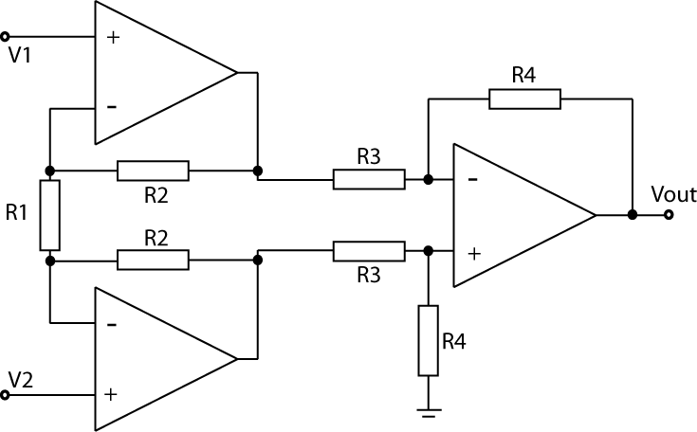

Figure 1

1. This question relates to the design of an instrument for detecting DNA.

1. Explain two methods which can be used to detect DNA, describing the physical phenomena which allow these detection methods.

[4]

1. Next generation sequencing has been enabled due to the design of Ion Sensitive Field Effect Transistors (ISFETs) which allows detection of pH. Sketch both the cross section of an ISFET and its macro-model, explaining its principle of operation and detailing equations of its drain current.

[6]

1. Figure 2 show a typical reaction where there is a change in pH caused by DNA binding to its complementary pair. The output voltage shown is linearly dependent on the pH change.
   1. Sketch a suitable instrumentation system to interface to an ISFET for this reaction explaining its operation.

[4]

* 1. What is the total change in pH because of this reaction.

[2]

1. A Reference-FET (REFET) is identical to an ISFET but insensitive to pH such that it can be used to create a differential circuit which can subtract any common mode noise in the reaction. Sketch a circuit comprising of an ISFET and REFET capable of outputting a voltage signal dependent only on the pH change of the reaction.

[4]



Figure 2

1. This question relates to the design of an electrical stimulation circuit for a cochlear implant.
2. Briefly discuss the relative advantages and disadvantages of using a monopolar vs. a bipolar electrode configuration for this application with a 22-electrode linear array. [5]
3. The desired stimulation pattern is shown in Figure 3. You are required to design a circuit to generate and deliver a stimulus considering the following specifications:

Stimulation type: Current-controlled

Electrode configuration scheme: bipolar

Electrode impedance: 10kΩ (assuming purely resistive)

Maximum current output (iMax): 1mA

Stimulus magnitude programmability: 2-bit

Sketch the design for a single channel (i.e. circuit schematic) providing a truth table, state transition diagram and/or combinational logic expressions for the controller. [10]

1. If your stimulator design achieves a charge balance of ~1%, describe how any residual charge can be removed and how this can be incorporated within your design. [5]

Stim_Figure1.pdf

Figure 3

1. This question relates to an implantable Brain Machine Interface (BMI) for motor control.

The front-end architecture of a single channel is shown in Figure 4. This has been designed to interface with a multi-electrode array to observe **only** the *Extracellular Action Potentials (EAPs)* and **not** the *Local Field Potentials (LFPs)*. The front-end includes a front-end bio-potential amplifier (A1), a bandpass filter (to reject the LFPs), a second amplification stage (A2) and an Analogue to Digital Converter (ADC) to digitize the signal.

1. Given the signal characteristics and circuit constraints detailed in Figure 4, determine appropriate values for the gains (A1 and A2) and ADC Resolution (X) and Sampling rate (Y). State any assumptions made. [7]
2. If the system is to utilize a transcutaneous biotelemetry (for data output) with a 2Mbit/s data-rate, calculate how many channels can be supported (based on your answer to part (a)). [3]
3. Detail how the system could be modified to support a higher channel count (for the 2Mbit/s data rate) given that the features of interest are the EAP spike shapes and inter-spike intervals. Your answer should include a block-level diagram in describing the amended system. [7]
4. State three reasons why it is *essential* for such a system to have low power consumption? [3]

BMI.pdf

Figure 4

1. This question relates to the design of an artificial pancreas for treatment of diabetes.

a)

i) Sketch a system level diagram of a closed loop system which works as an artificial pancreas and describe its operation.

[5]

ii) Explain three main disturbances to the system which would cause the blood glucose to fluctuate.

[3]

iii) Explain one challenge that is faced with current technology.

[2]

b)

The blood glucose of a diabetic is expected to fluctuate in the range of 0-20mM. A continuous glucose sensor consists of an enzyme which can generate 10nA of current for every 1mM of glucose when biased with a redox potential of 700mV. Design a complete instrumentation system to sense blood glucose using this enzyme which works off a 3V supply and maximizes the dynamic range available.

[10]